“ No individual should have to bear a disproportionate share of the cost of HS2 by suffering personal loss in the value of their property, for a scheme the Government says is in the national interest”
Hilary Wharf, Director, HS2AA on fair compensation

2012 Compensation Consultation
On October 25th 2012 the Government commenced a consultation on compensation arrangements which it proposes will operate in areas impacted by Phase 1 of HS2.
A summary of what’s on offer is set out on this page. You can review a short presentation of the key points here.
This consultation is important – it is the last chance for people to have their say on how compensation arrangements should operate. After the consultation, that ends 31 January 2013 the Government will bring a finalised scheme into effect which will operate until the line is up and running a year – a period of 15 to 20 years – 2027 at the earliest.
Unsurprisingly the Government have claimed their proposed scheme is ‘generous’; recognises the ‘exceptional nature of HS2’ (eg the long timescales for construction); and is ‘comparable with HS1’
HS2AA’s verdict is different. We believe the Government’s proposals
- Are very disappointing – merely a rehash of existing statutory rules and past failures, with rules that are worse than both those used for communities impacted by Britain’s only other high speed railway (known as HS1) and by the current interim scheme for communities affected by HS2, known as the Exceptional Hardship Scheme (EHS).
- Indicate that, despite the spin, they are simply ignoring the realities of the property blight.
- Renege on past promises to introduce fair compensation that ensure people don’t suffer significant losses and indeed address ‘any blight’ caused by its proposals for HS2
- Rely on arbitrary geographic boundaries or hardship criteria to decide who gets compensation rather than the test of actual loss in market value
- Lack the evidence to show the real extent of blight and why it is not being compensated.
If the proposals being consulted on are implemented, the vast majority of those who suffer losses stay trapped for 15 or more years in their homes with no compensation:
- Of the 170,000 plus households within a kilometre of the line, or 250m from a tunnel, less than 2,000 will qualify to be purchased.
- About 600 more may qualify under the ‘hardship’ scheme (based on DfTs budgeted figure for the proposed schemes) –suggesting a similar uptake as under EHS (ie 40 cases/a).
- Its noted even DfT/HS2 Ltd contacted the 43,000 properties that lie within 500 metres (or 150m in urban or tunnelled areas) about this consultation.
HS2AA believe this simply isn’t fair. Individuals should not have to bear a disproportionate cost of HS2 by suffering personal loss in the value of their property, given the scheme is said to be in the national interest. It is therefore vital that as many people as possible respond to the current consultation and make the case for fair compensation.
- What is the Government Proposing?
The Government is proposing different arrangements for households, depending on their distance from the line. Their consultation materials illustrate these arrangements as follows:

Overview of owner-occupier arrangements
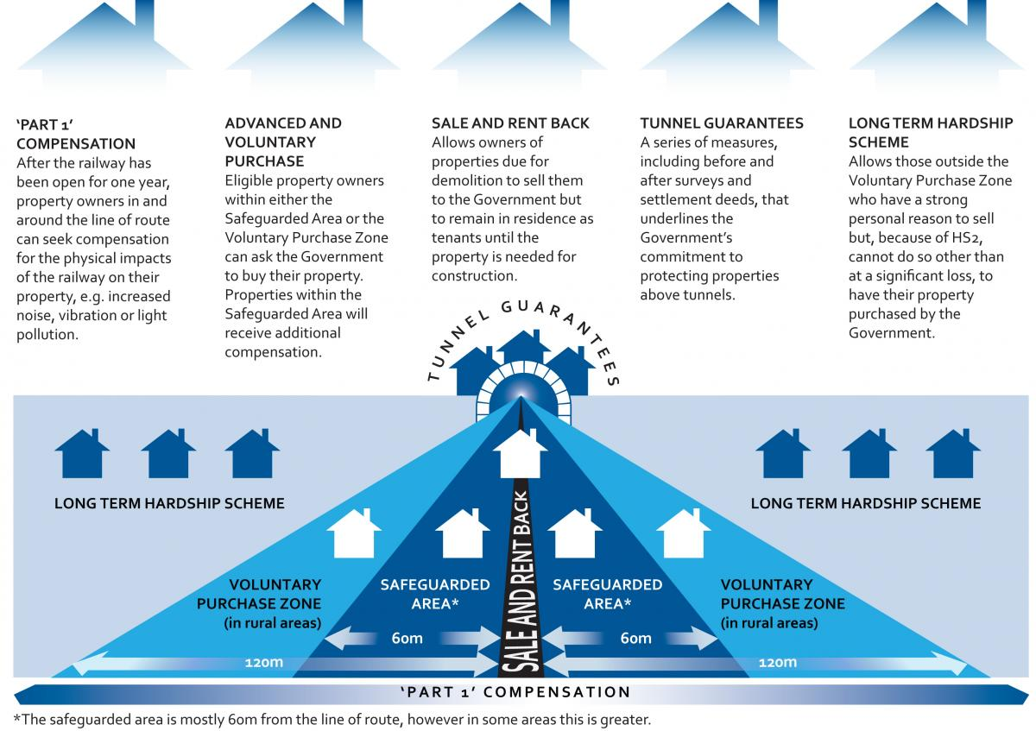
- What happens in each category?
Safeguarded Zone (SZ)
Where is it? | It is 60 metres from the centre of the proposed line unless HS2 construction or engineering requirements mean a greater area is required (as in some places).  It also covers 30 metres for deep tunnels.  HS2 Ltd say the SZ comprises 1101 properties. Some (338) will definitely need to be demolished for HS2, others may not eventually need to be demolished.
Who’s eligible? | Owner occupiers of homes; owner occupiers of small businesses (ie businesses located in premises with a rateable value of less than £34,800) and of agricultural units; mortgage lenders and ‘personal representatives’ ie persons acting for someone who has died.  Others may qualify but only if they are going to be actually demolished and they must wait until the property is actually needed
What is the compensation? | An Advanced Purchase Scheme, where HS2 Ltd can be required to buy eligible properties when the area is “safeguarded” ie before the properties are actually needed for construction purposes.
What compensation is provided? | HS2 Ltd will (1) purchase at the unblighted (ie unaffected by HS2) price; (2) pay a home loss payment, which is capped at 10% of the property’s value or £47,000, whichever the lesser amount, (3) pay moving costs.
Any other features? | For properties partly inside the Safeguarding Zone a case by case approach applies – it’s likely to count unless it has an exceptionally large garden and only a small part is inside the Safeguarded Zone.  HS2 Ltd will offer a Sale and Rent back option for homes in the zone that will be demolished, provided they can meet renting standards, so occupants can reside in the property as tenants until it is required.
What’s wrong with it? | For compulsory purchase properties, these arrangements are simply your legal rights, which are being spun by Government as a generous settlement.  Inadequate clarity on criteria or eligibility for properties only partly inside the zone.  Unfair to exclude rented out homes, including when it’s a main home and you moved to rent another, or second homes (that aren’t being demolished).  Sale and Rent back should include homes not demolished and small businesses. Owners beyond the safeguarding zone should be eligible - it gives HS2 Ltd a ready-made tenant in otherwise hard-to-let properties.  Businesses are poorly treated. Nothing for loss of profits, whether purchased or not by HS2 Ltd.

Voluntary Purchase Zone (VPZ)
Where is it? | Land up to 120 metres from centre line in ‘rural’ areas and not over bored tunnels ie only for properties located between the M25 and the junction with West Coast Main Line in Staffordshire. Properties located in London or on the approach to Birmingham are excluded.  HS2 Ltd say 813 properties in total are located in this zone.
Who’s eligible? | Owner occupiers of homes; owner occupiers of small businesses (ie businesses in premises with a rateable value of less than £34,800) and of agricultural units.
What compensation is provided? | HS2 Ltd will purchase the affected property at the unblighted (ie unaffected by HS2) price. This price will be calculated by reference to the average of two valuations (three if the first two are over 10% apart) paid for by HS2 Ltd.
Any other features? | For properties partly inside the VPZ a case by case approach applies – it’s likely to count unless it has an exceptionally large garden and only a small part is located in the VPZ
What’s wrong with it? | It doesn’t deal with the different market losses arising from HS2. The size of the VPZ should be set by ‘market loss’ rather than arbitrary geographic distance limits.  No evidence is provided to justify that the VPZ reflects the extent of blight. Greater or equal losses will be suffered by those outside the zone.  The distance is too little to reflect the market loss impacts. In some rural areas there might not be a VPZ at all if the Safeguarding Zone is wider than 60 metres.  120 metres is an arbitrary cut off, which ignores different topography (open fields versus roads); different impacts of HS2 (eg viaduct, cutting, on surface); losses cover a more extensive area in many places  It’s unfair to exclude urban blight, many properties will suffer similar losses.  It fails to meet previous Government commitments to compensate for all ‘significant’ loss, which would require the boundary to be instead set by reference to a percentage market loss eg 10%. Contours of loss should have been provided  No compensation for losses suffered by the community or properties affected by the lengthy construction period– some camps and sites and road disruption will last many years.  Unfair to exclude homes which have been rented out (even when it’s your only property); and second homes (this maybe someone’s pension pot).  Inadequate clarity on criteria or eligibility for properties only partly inside the Zone.  No other costs paid (moving, or home-loss payment), on the basis it’s your choice to move. But this makes it worse than the Voluntary Purchase Zone used in 1988 for HS1 that matched the statutory payments regime – so it’s not comparable with HS1 as the Department for Transport claim

Long Term Hardship Scheme Zone
Where is it? | Properties located outside the Safeguarding Zone and beyond any 120 metre Voluntary Purchase Zone (in rural areas).
Who’s eligible? | Owner-occupiers whose property is ‘substantially adversely affected by the construction/operation of HS2’ and who have “strong personal reasons” to sell
What compensation is provided? | HS2 Ltd will purchase the affected property at the unblighted (ie unaffected by HS2) price. This price will be calculated by reference to the average of two valuations (three if the first two are over 10% apart) paid for by HS2 ltd
Any other features? | Applicants must demonstrate ‘hardship’ if they don’t sell (eg medical reasons, relocate for job, upsizing, downsizing as can’t afford current property etc)  The property must be on the market for 12 months and no offer received within 15% of unblighted market price. It must also be proved that the reason for no sale is the property’s proximity to HS2 and the applicant must not have been aware of HS2 when it was purchased. Unlike EHS ‘urgency of sale’ is no longer a criteria
What’s wrong with it? | The scheme will exclude the vast majority who suffer loss in property value. No cost or other evidence is provided to justify criteria that go beyond those related to market loss due to HS2 eg the hardship criteria  HS2 Ltd’s own figures confirm over 170,000 households are located within 1km of the route of the proposed line or 250m of tunnel (one quarter of whom lie within 500m, or 150m in urban or tunnel areas) yet less than 2000 will be guaranteed help under the purchase zone arrangements. The current £1.3bn total budget suggests a similar uptake under the hardship scheme as under the existing EHS ie about 40 properties a year. So in total very few of those affected will qualify.  The property criteria should not exclude small businesses, second homes, rented out properties (even if your only property) and other businesses.  The location criteria should be determined by evidence of ‘market loss’ due to HS2 – it’s fairer and more transparent than ‘substantially adversely affected’ that relies on physical detriment.  The hardship criteria are unreasonable given the timescales involved with HS2, and its overriding purpose ie to compensate people who suffer property blight as a result of HS2. The criteria should be removed. There is precedent for this in schemes approved by DfT (eg BAA scheme after objections during consultation)  People should be free to move home/remortgate like any other citizen in the 15 or more year period which it will take to construct and then operate HS2 for a year.  No formal appeals process is unfair, evidence from EHS shows one is needed.  No additional moving related expenses are covered  The 15% loss threshold should be lower – it’s roughly a pre-tax year’s salary.  The ‘no prior knowledge’ criteria bakes in the blight and depresses property prices  Arrangements are stricter even than EHS or other schemes used for projects such as Crossrail, Thames Tunnel eg the requirement that a property must be marketed for 12 months (compared to 3 months for EHS), excluding small businesses that all other schemes include.  It is inappropriate to set the marketing figure (of 12months) based on a view of the current property market when this scheme is to last for 15years or more.  The scheme is confined to purchase. There is nothing for suffering the long term blight from its construction for those who stay eg dust, camps, road diversions.

Tunnel Guarantees
Where is it? | Properties 30m either side of centre line in Safeguarded Zone over the deep bore tunnel
Who’s eligible? | All properties in 30m zone for a Settlement Deed and for Subsoil Purchase. HS2 ltd decide the ‘at risk’ properties for the Surveys
What is provided? | Before and after Surveys for ‘at risk’ properties from tunnelling damage  Settlement Deed: accepting responsibility for tunnelling damage (settlement, subsidence and vibration)  Subsoil Purchase: token sum eg £50 and a £250 towards fees for expert advice
What’s wrong with it? | This is about reassurance, not compensation (which is a token sum only)  While the settlement deed itself may reflect concerns raised in relation to HS2 tunnelling, what it provides is only your statutory entitlement ie to have any tunnelling impacts on your property put right  Property blight is left unaddressed eg aversion to coping with remedial works etc  Deed and surveys make no mention of protection from long term operational impacts eg vibration

Finally there is statutory (Part 1) compensation that applies a year after HS2 is operating (ie in the late-2020s). But typically this is small (maybe 5% of property price), only for those close to the line and importantly is based on only the physical effects of HS2 and not the market loss in price (which will include loss of amenity, view, tranquillity and aversion factors). This should be updated to be based on market loss. If the Government believe the mitigated HS2 railway will have minimal impact, then the cost implications will be correspondingly minimal.
- What’s the Government really offering?
Cutting through the spin its clear the Government has broadly just given those impacted their statutory rights, and used the precedent established in other schemes (eg HS1, EHS, Crossrail and others) with little else.
It’s hard to see how this package justifies the delays or how it recognises the ‘exceptional nature’ of HS2. It’s compensated the 1900 most affected properties (using a crude geographic boundary) but left tens of thousands with little chance of recovering their loss or getting on with their lives.
Minimal improvements (confined to handful of circumstances eg sale and rent back) don’t hide the fact that there has been a material worsening for the majority of affected properties. The decision to make the hardship scheme (the only scheme for most who are blighted) worse than the current EHS and 20 year old HS1 scheme is a stark indication of Government’s real intentions on ‘generosity’.

Even those that suffer the construction (for which they get nothing) but can seek statutory compensation when HS2 has been running a year, will not be entitled to their market loss in value.

HS2AA believe the Department for Transport have no excuse for this position. HS1 was built 20 years ago, and the resulting problems with blight were so well known within Whitehall that an inter-departmental committee was set up to look at the issue and determine a better way forward. Over the following 20 years knowledge of blight has only increased through numerous airport and road schemes as well as the construction of Crossrail, and most recently Thames Tunnel.

The Department for Transport also had the chance to review a Property Bond scheme, which was suggested by HS2AA and others, that the inter-departmental committee judged as “coming closer than any other to addressing blight concerns”. Yet while it might be best practice in the private sector and endorsed by the professionals – The Council of Mortgage Lenders, British Banking Association and National Association of Estate Agents – it was rejected by Government for HS2 on grounds of risk and cost.

- HS2AA’s perspective
HS2AA are calling for a total rethink on what’s on offer to address the issues highlighted above. We believe qualification for compensation should be driven by ‘market loss’ rather than arbitrary geographic distance boundaries or recourse to hardship rules for the majority affected. To propose schemes for HS2 that are even worse than past precedents is totally unacceptable.
We are also appealing to Government to take a more imaginative and honest approach to the issue, with measures like
- Stamp duty holidays to encourage the continued functioning of the property market in the worst impacted areas
- Community funds for areas forced to endure years of construction
- Government undertaking to publish independent and verifiable research to show the extent of blight, using Isoloss contour maps. It should then honour the previous Secretary of State for Transport, Philip Hammond, promise to ensure no individual suffers significant loss as a result of HS2
- Coming clean on the cost of a Property Bond – HS2AA believe the cost would be manageable. The Bond would provide reassurance and some of those in the VPZ might not then ask to be purchased. Government’s can withstand the long build timescales in a way that individuals can’t, especially if HS2 is in the national interest.
- Properly addressing the interests of small businesses, agricultural premises and social housing and landlords. In particular social housing tenants impacted by the line should be entitled to a rent review and social landlords given the funds required to construct alternative accommodation.
It can’t be right that individuals from every social background should have to personally suffer a disproportionate share of the cost of HS2.

HS2AA will be working with other groups interested in fair compensation to maximise responses to the current consultation. We are hoping to make clear to the Government that their current proposals are not acceptable.

- Consultation Process

You can respond
online at http://highspeedrail.dft.gov.uk or
via e-mail by sending responses to hs2propertyconsultation@dialoguebydesign.com or
in writing by post to FREEPOST HS2 PROPERTY AND COMPENSATION CONSULTATION

You can phone 0300 123 1102 for more forms

- What materials are available from HS2 Ltd?

The main consultation document: HS2: Property and Compensation for London to West Midlands
The Response Form
Five Fact Sheets – one for each Scheme that summarise what is in the main document:
Safeguarding; Sale and Rent back; Advanced and Voluntary Purchase Schemes; Hardship Scheme; Tunnel Guarantees
The Explanatory Notes to the Safeguarded area Maps: General notes on the Draft Safeguarded Area – this has notes on each of the maps
The 107 maps in several volumes that cover the whole of Phase 1

